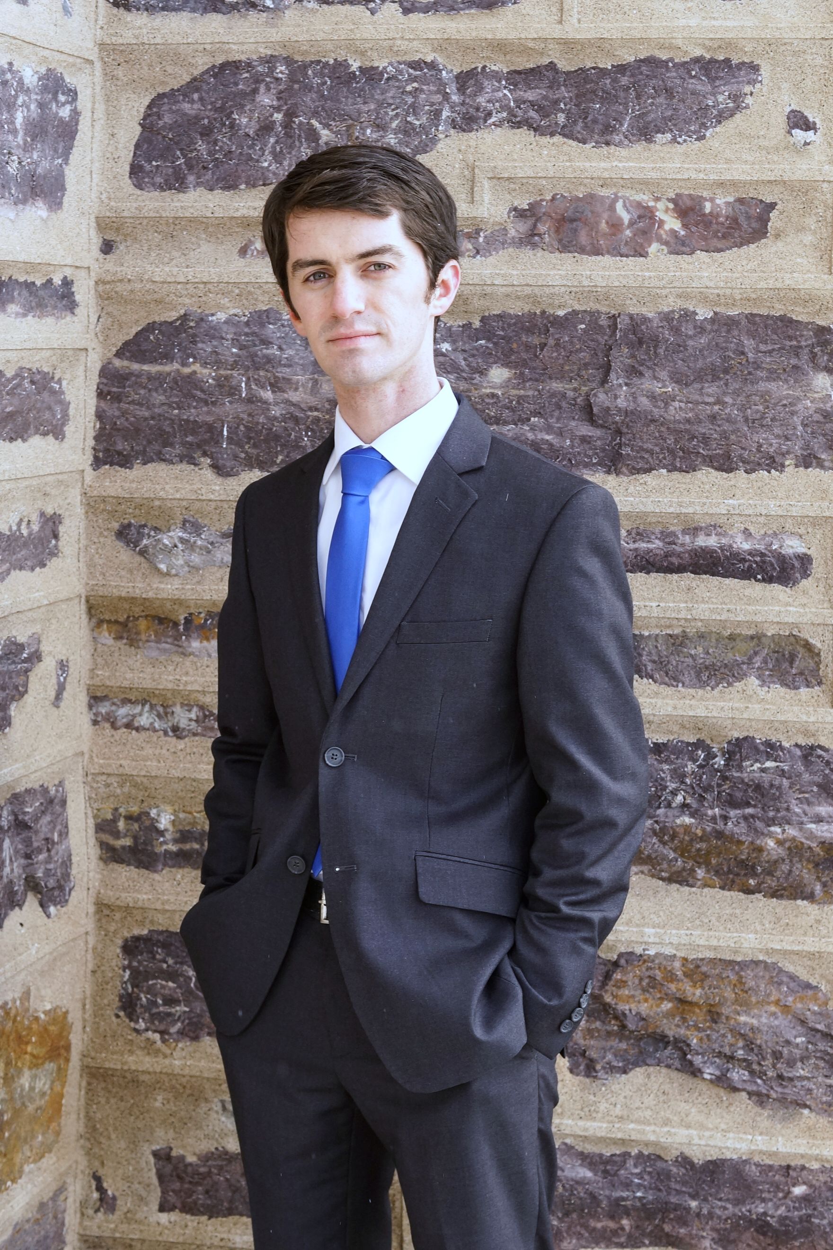

**Matthew F. DeAngelo**

MFDeAngelo@yahoo.com

(801) 699-0797

I’m a highly self motivated person. I love learning about anything I can get my hands on.

**C# .NET**

Disposable Pattern, LINQ, Async/Await

**Design Patterns**

Decorator, Factory,

Observer

**Git**

Branching, Pull Requests, Code Reviews

**Misc**

Python, Vue, Java, HTML5, Node.js

**Certifications**

CompTIA Security+

**Favorite Data Types**

Stream &

IEnumerable<T>

**Work Experience**

Forensic Software Engineer, Cipher Tech Solutions Sept 2020 – Present

* Met with clients to identify needs and determine application requirements
* Architected, designed, wrote, and maintained multiple applications concurrently
* Presented product workflow to prospective customers and upper management
* Created solutions to problems with minimal concrete requirements

Software Engineer, Ajoules May 2019 – Sept 2020

* Reverse engineered a file specification to encourage clients to migrate
* Implemented security rules on a Firebase server to protect user data
* Utilized 3rd party libraries and frameworks such as Firebase, Ionic and Vue

Recitation Leader, Utah State University Jan 2017 – May 2020

* Lead classrooms of 30+ students in discussions on mathematics
* Presented complex information in a simplified manner to facilitate learning
* Mentored students to promote academic confidence

Software Development Intern, Corporation of the Church May 2018 – Aug 2018

* Created hundreds of unit tests to inspire confidence when altering the code base
* Performed rudimentary penetration tests and identified 2 critical security threats
* Reduced duplicate code by creating utility libraries

**Projects**

80% Tool – Media file reducer and organizer Oct 2020 – Present

* Implemented as a set of removable modules to better enable reuse
* Developed a filtering algorithm novel to the industry that archives useless photos
* Reduces manual workload by 85%, yielding a 6% faster overall response

Werewolf – Excel report parser Sept 2021 – Present

* Architected to parse and cross correlate data in a layered approach
* Reduced a 30-minute manual process to under 30 seconds
* Worked alongside non-technical users to obtain requirements

Cellebrite Searcher – Extracts files from Cellebrite images Jul 2021 – Nov 2021

* Solved an issue plaguing the forensics community for over 2 years
* Uncovered the uses of an undocumented library via trial and error
* Facilitated the process of extracting mission critical files

**Education**

Honors Bachelor of Science Sept 2016 – May 2020

Mathematics Major and Computer Science Minor GPA 3.89

Utah State University *Magna Cum Laude*

**Books Read**

Clean Code: A Handbook of Agile Software Craftsmanship by Robert C. Martin

Effective C#: 50 Specific Ways to Improve Your C# by Bill Wagner

Head First Design Patterns by Eric Freeman

Code: The Hidden Language of Computer Hardware and Software by Charles Petzold